SAFE Reusable Repository

Type of Object – SAP NW Gateway

**Description – Implement Batch Operation**

Process – Update Outbound delivery

Sub Process – Update selected items of an outbound delivery

DOCUMENT ORIGIN

|  |  |
| --- | --- |
| AUTHOR | OPERATION UNIT |
| Suprio Chatterjee | SAP – APPS TWO |

CHANGE HISTORY

|  |  |  |
| --- | --- | --- |
| VERSION | DATE | CHANGES |
| 1.0 | 23.11.2015 | Final version |
|  |  |  |

REVIEW AND APPROVAL

|  |  |  |  |  |
| --- | --- | --- | --- | --- |
| COMPANY | NAME | ROLE | DATE | SIGNATURE |
| Capgemini, Kolkata | Suprio Chatterjee | ABAP & Gateway Developer | 23.11.2015 | Suprio Chatterjee |
|  |  |  |  |  |

# Introduction

It is sometimes required to group a sequence of operations into a Batch and execute in the same Change Set.

The process explained in this document involves the implementation of Batch operation for a particular scenario to group multiple update operations into the same change set.

# Prerequisites

* The developer should have flair knowledge of the Gateway Service Builder environment
* The developer should have flair knowledge in ABAP and OOPS

# Functional Requirement

The sub-application was required to update an existing outbound delivery document in the SAP based on user data sent from the frontend UI5.

## Create an RFC to change an item of an Outbound delivery

### RF C ZLMM_OUTB_DELIV_ITEM_UPDATE is developed to change an Outbound delivery item with below parameters,

### Import Parameters:

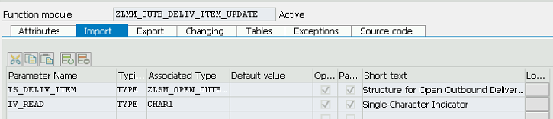

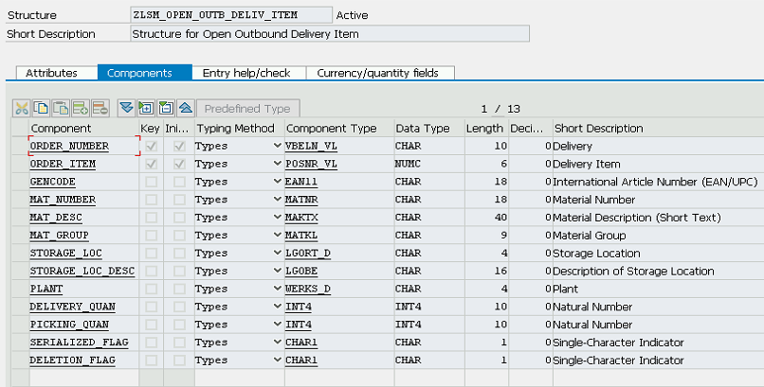

### Tables:

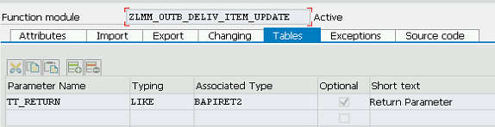

### Source Code Snippet:

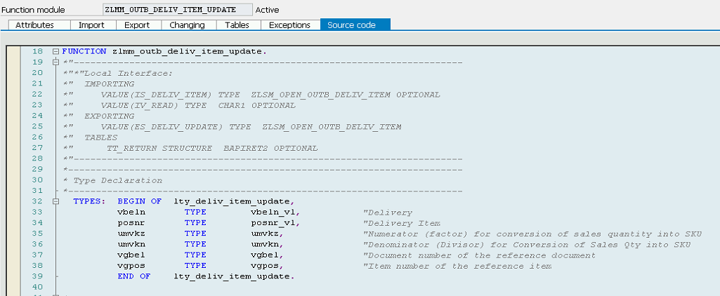

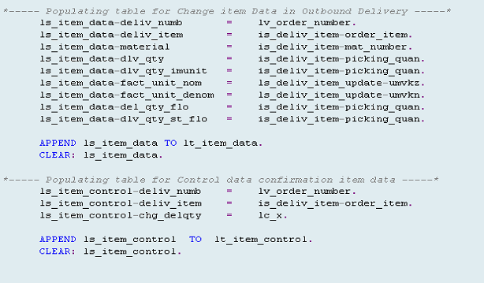

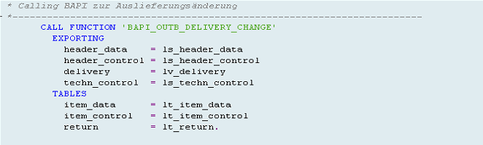

## Create a Project in Gateway service Builder with defined entity type

### Project ZGW_OUTBOUND_DELIVERY_LIST consist of an entity type ZOUTBDELIVITEM with properties fetched from RFC ZLMM_OUTB_DELIV_ITEM_UPDATE through Import RFC functionality in Gateway service builder

### 

## Implement Update Entity service mapping the RFC properties,

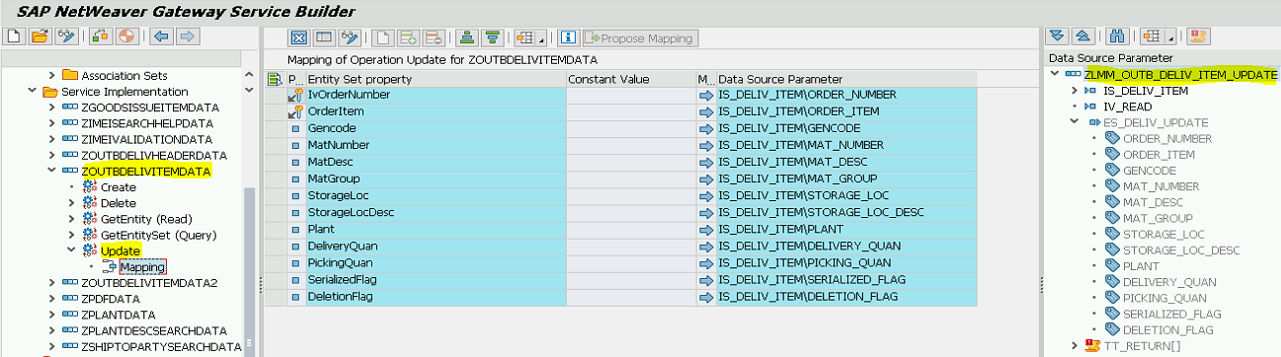

## Generate Run time artifacts

### Generate the corresponding ZOUTBDELIVITEMDA_UPDATE_ENTITY method as below,

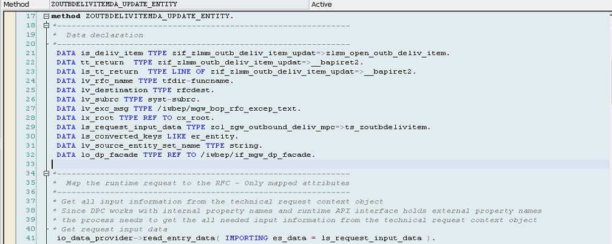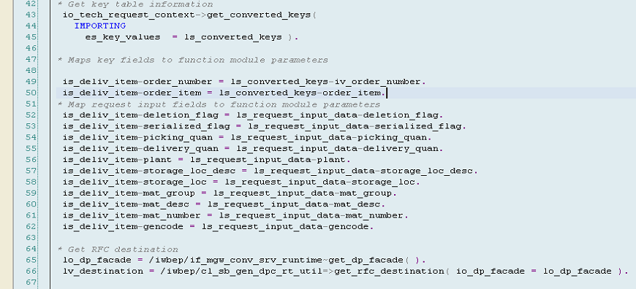

## 

## Implement two runtime methods changeset_begin and changeset_end for implementing all the operations of a batch in the same change set

### Changeset_begin

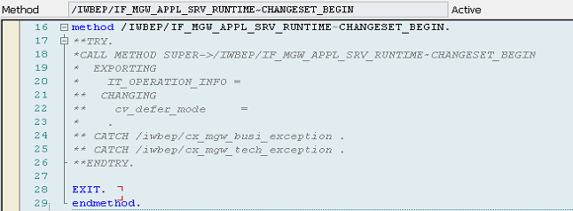

### Changeset_end

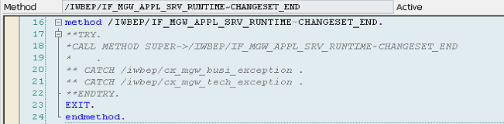

# Conclusion & Reference

This is a process of implementing batch operation grouping all the services say Create, Update,Read etc. in the same Change Set.

<http://www.sdn.sap.com/irj/scn/go/portal/prtroot/docs/library/uuid/40546820-3ea7-2f10-dfab-be373c0da357?overridelayout=true>